# ABC’s Inventory Management System

## Test Script

|  |  |  |  |  |  |
| --- | --- | --- | --- | --- | --- |
| **Test Name** | | Test Search Product Using Existing Product Code (Test Case SPT001) | | | |
| **Use Case Tested** | | Search Product | | | |
| **Test Description** | | This test tests if the system can retrieve product item details and contents in each location using a known product code that the product item belongs to. | | | |
| **Pre-Conditions** | | Meta data must exist, product and product details like product code, product item code, location ID and so on must exist. | | | |
| **Post-Conditions** | | Matching product item on each location displayed through product code i.e. matching product is displayed through which product items belonging to the product is viewed. | | | |
| **Notes** | | This test assumes that the user knows the product code exists.  This test allows users to view product items using a product code. | | | |
| **Result (Pass/Fail/Warning/ Incomplete)** | | Pass | | | |
|  | **Test Step** | | **Expected Test Results** | **P** | **F** |
| 1. | Open the ABCInventoryClient.exe file | | ABCInventoryClient system launches. | P |  |
| 2. | Type in the existing product code that is known by the user in the Product Code field of the system. | | System waits for the user to hit enter or click on the ‘Search’ button. | P |  |
| 3. | Hit enter or click on the ‘Search’ button. | | Product with matching product code is displayed with all other product details like total quantity, price, name, etc. along with the location details separated according to the location. | P |  |
| 4. | Click on details to check product item details in the desired location. | | Product Items’ details belonging to the product in the location that was selected is displayed. | P |  |

|  |  |  |  |
| --- | --- | --- | --- |
| **Test Data Table** | | | |
|  | **1** | **2** | **3** |
| **Product Code** | S1 | S1 | S2 |
| **Location ID** | STR1 | WRH1 | STR2 |
| **Location Name** | Oxford Store | Newtown | Epping |

# Result Screenshots

The screenshots of the result on each test step for each data set are given below:

## Data Set 1

**Step 1**

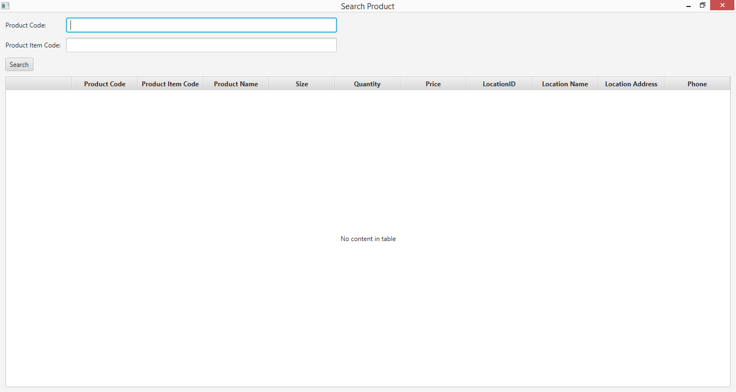

**Step 2**

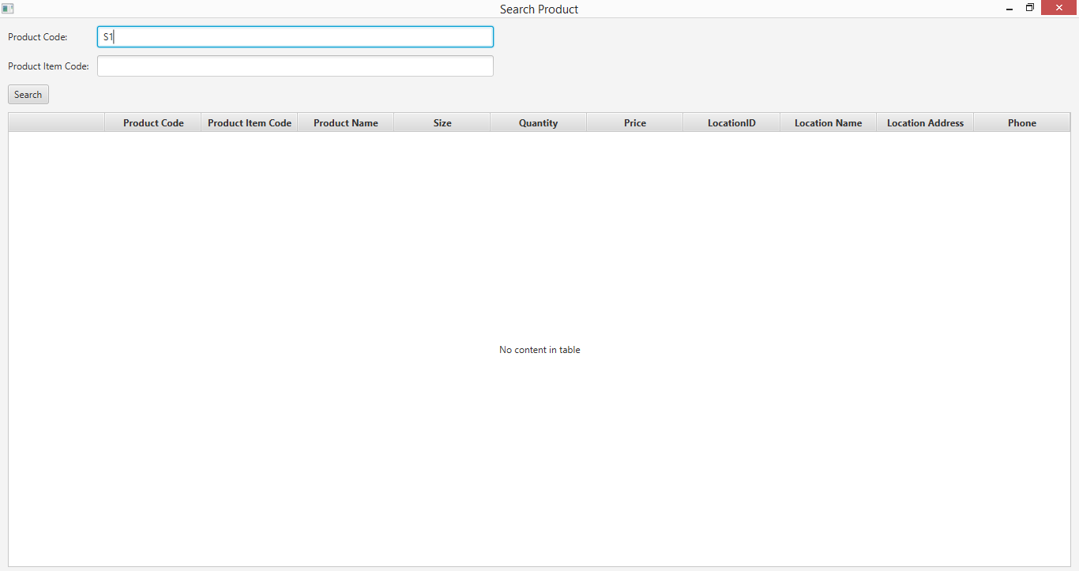

**Step 3**

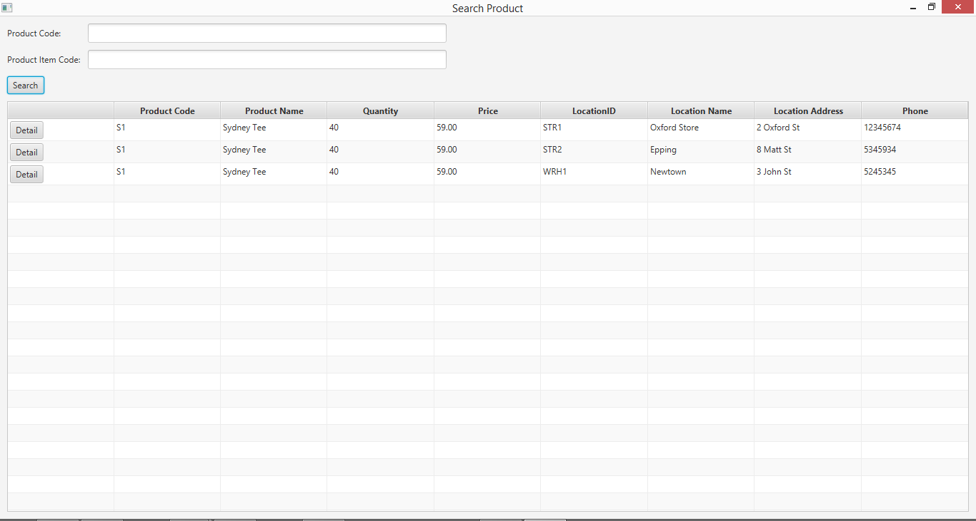

**Step 4**

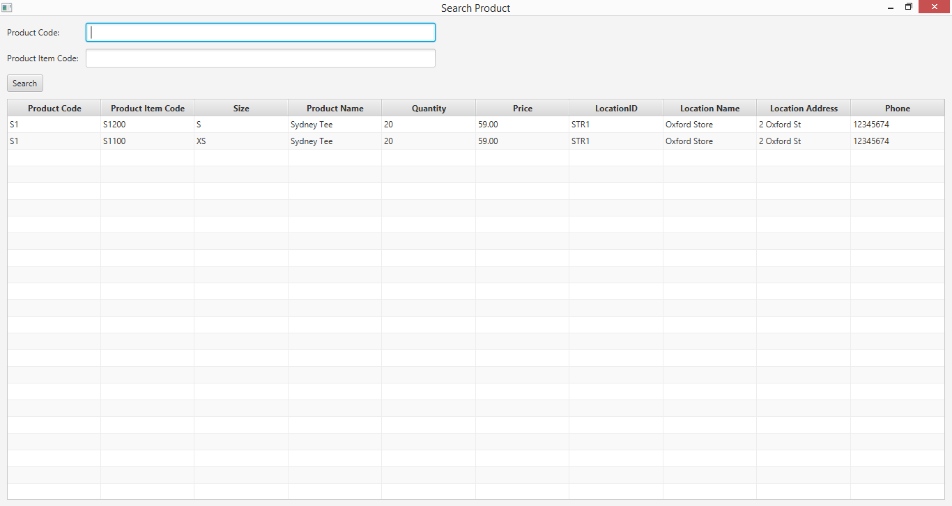

## Data Set 2

**Step 1**



**Step 2**



**Step 3**



**Step 4**

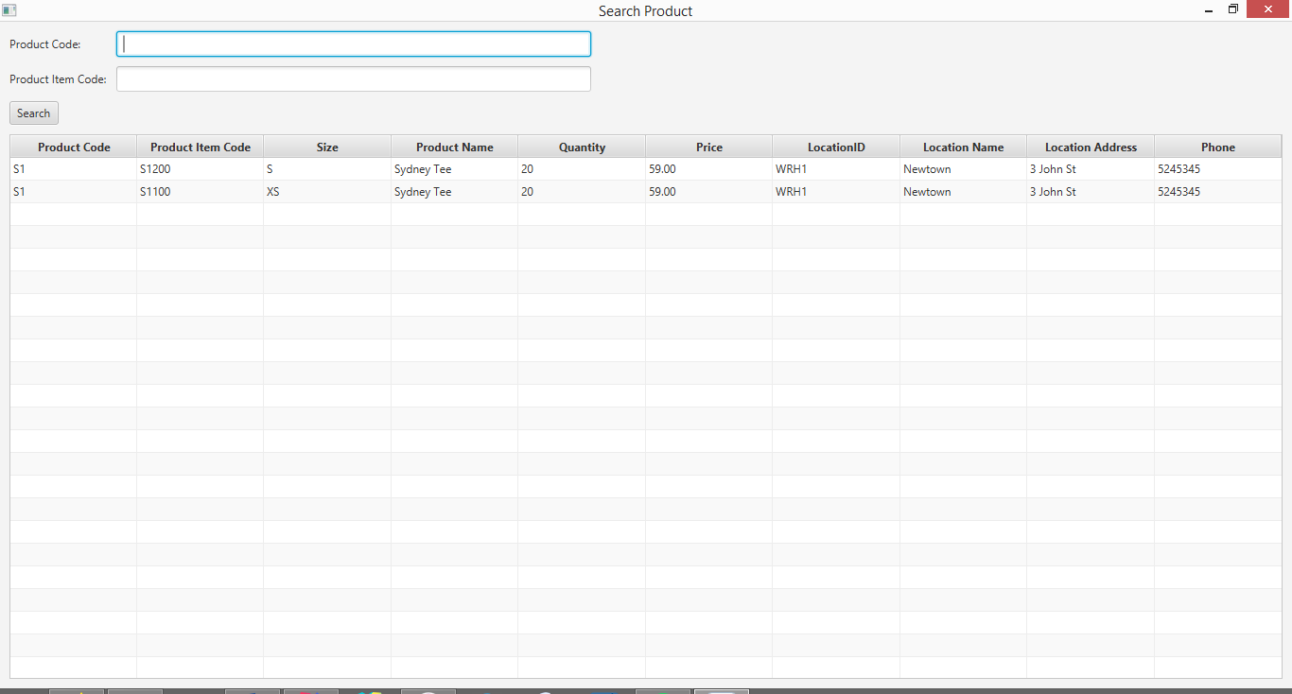

## Data Set 3

**Step 1**



**Step 2**

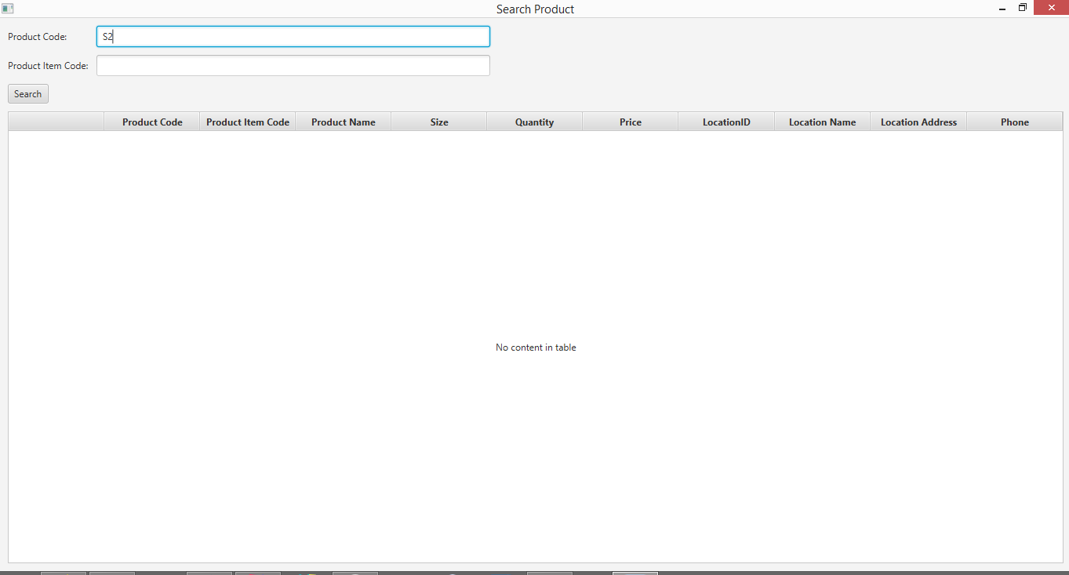

**Step 3**

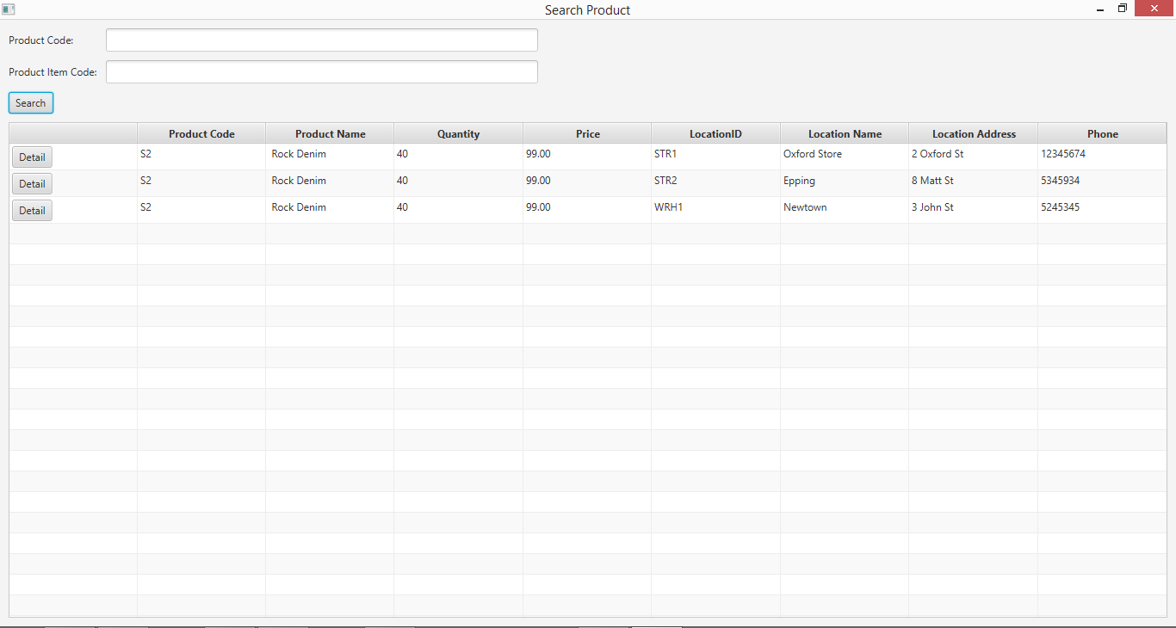

**Step 4**

